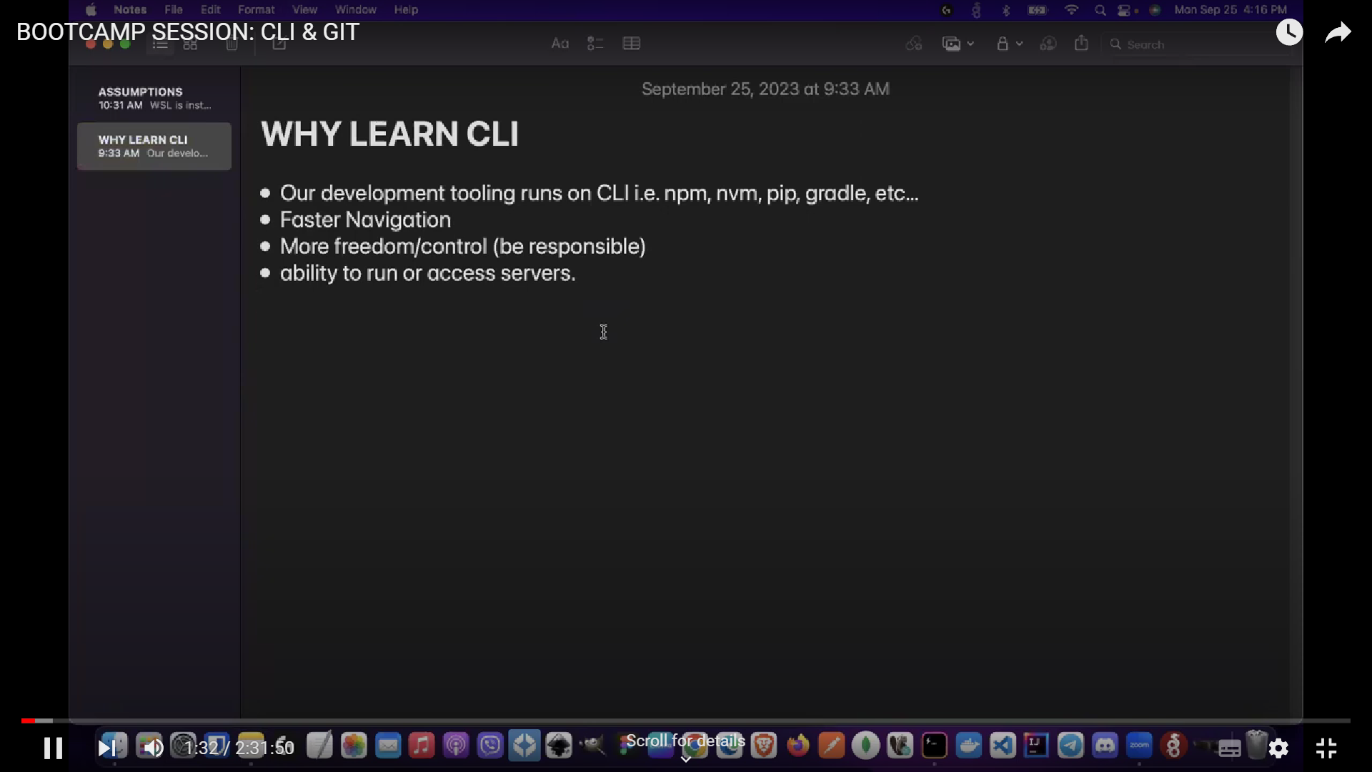

**Command Line Input (CLI)**

CLI is a command line program that accepts text input to execute operating system functions.

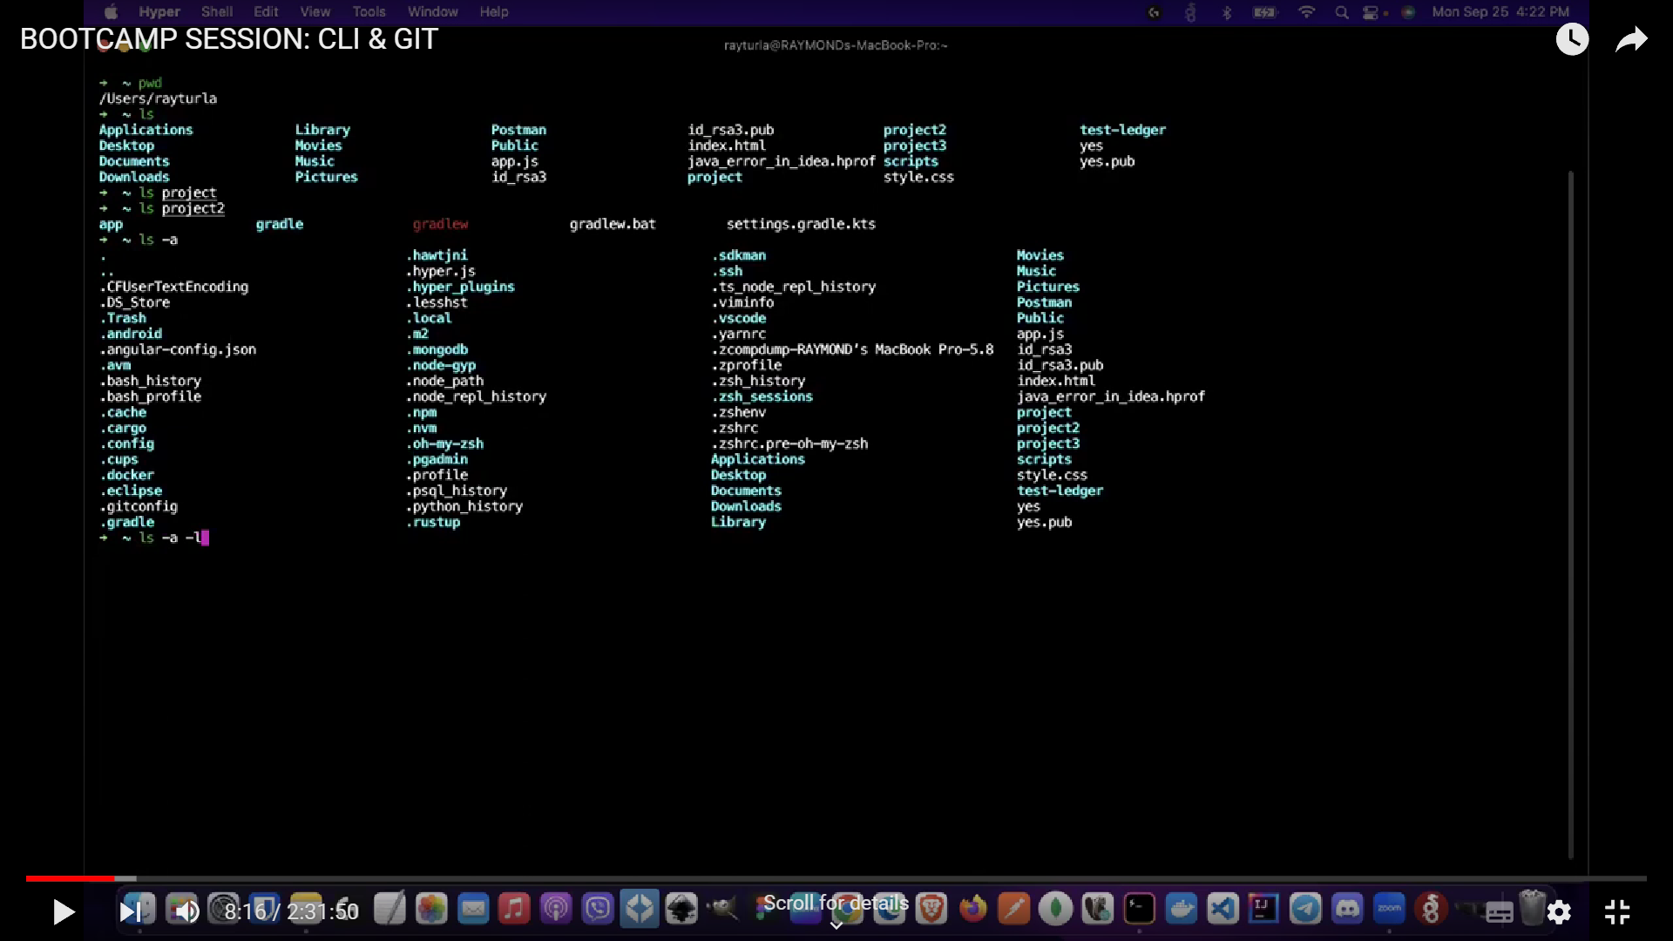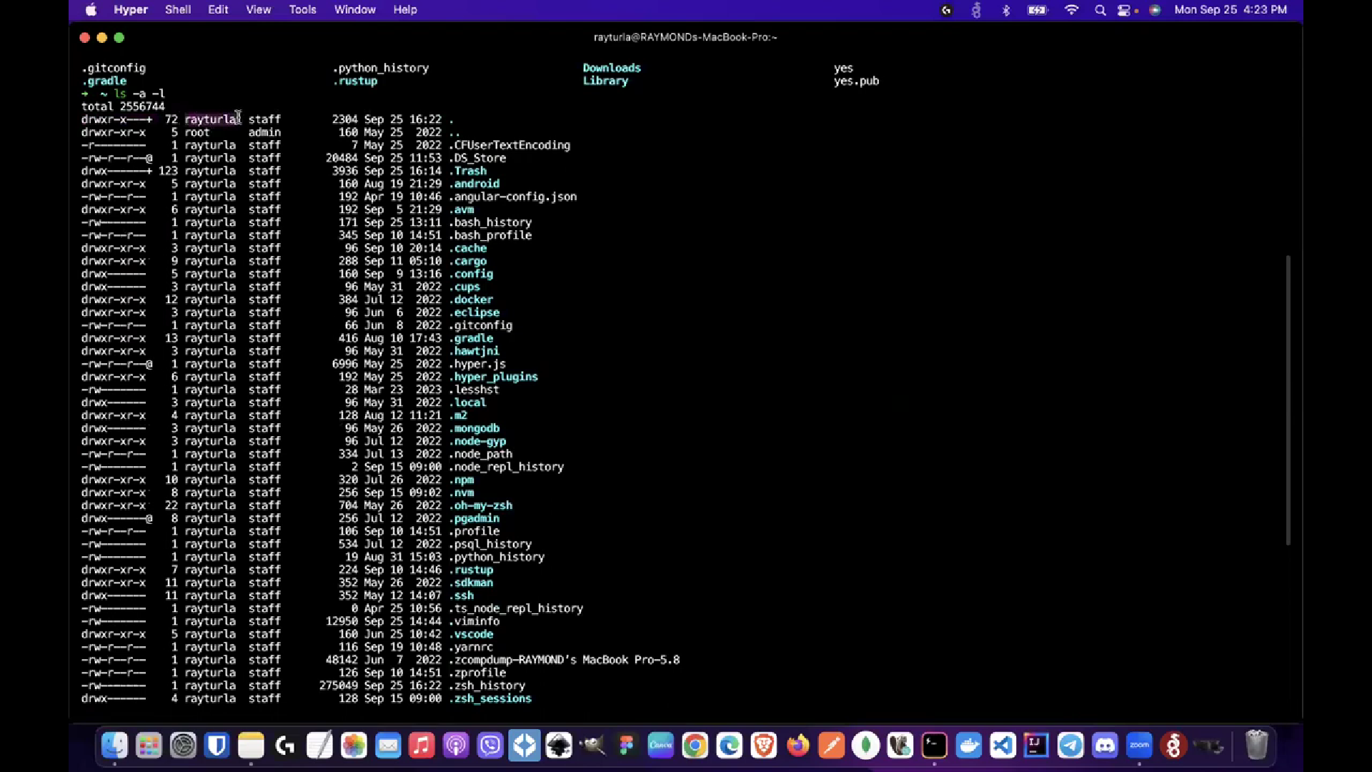

Pwd = current directory

Ls = content of that location

Ls (folder_name) = open the content of the folder

Ls -a = detailed view of the directory

Ls -a -l = detailved view of the directory with the hidden files included

Clear = clears the printed content

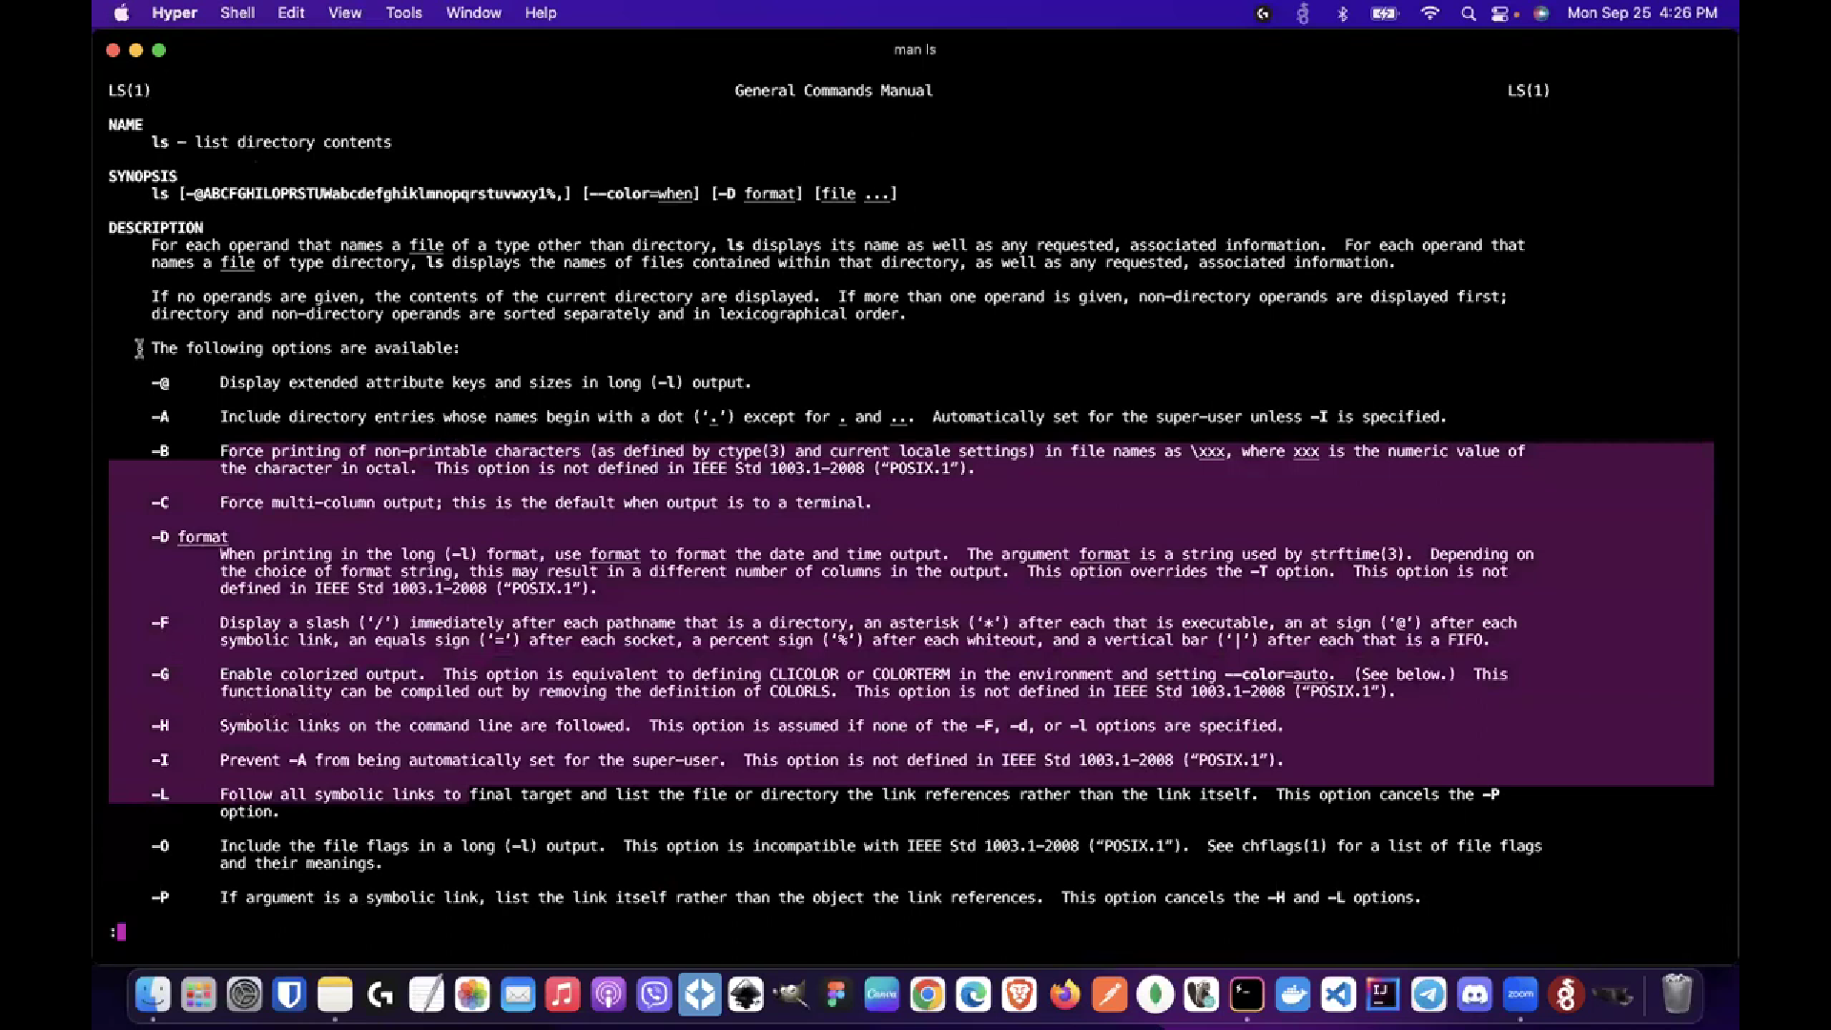

Mas ls = opens user manual for commands

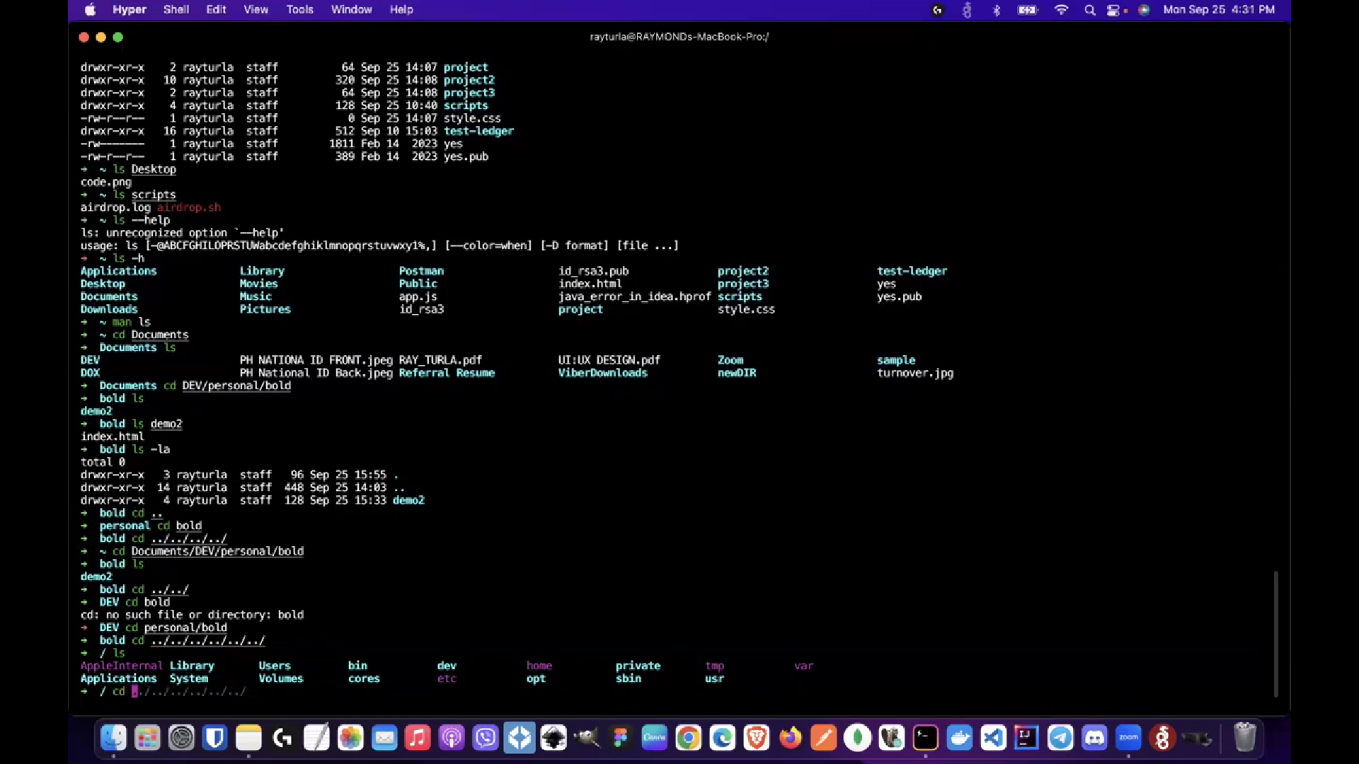

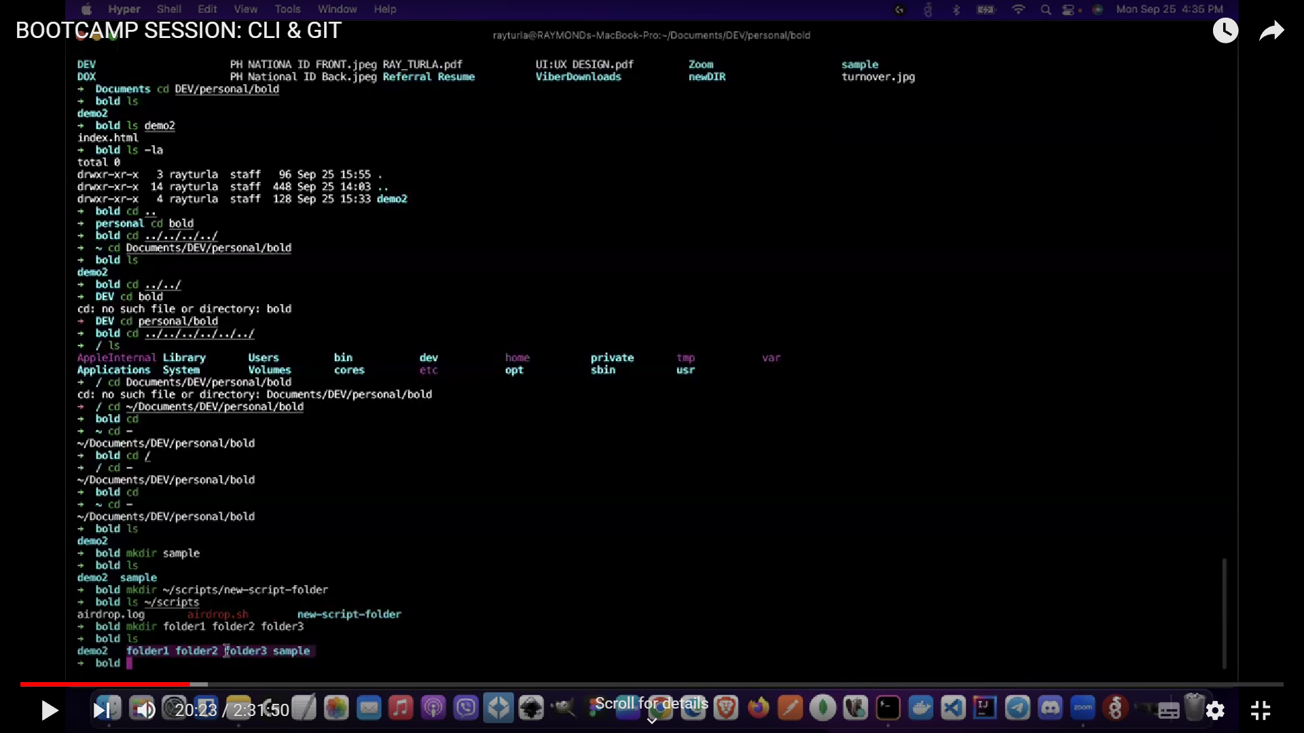

Mkdir = make directory (folder)

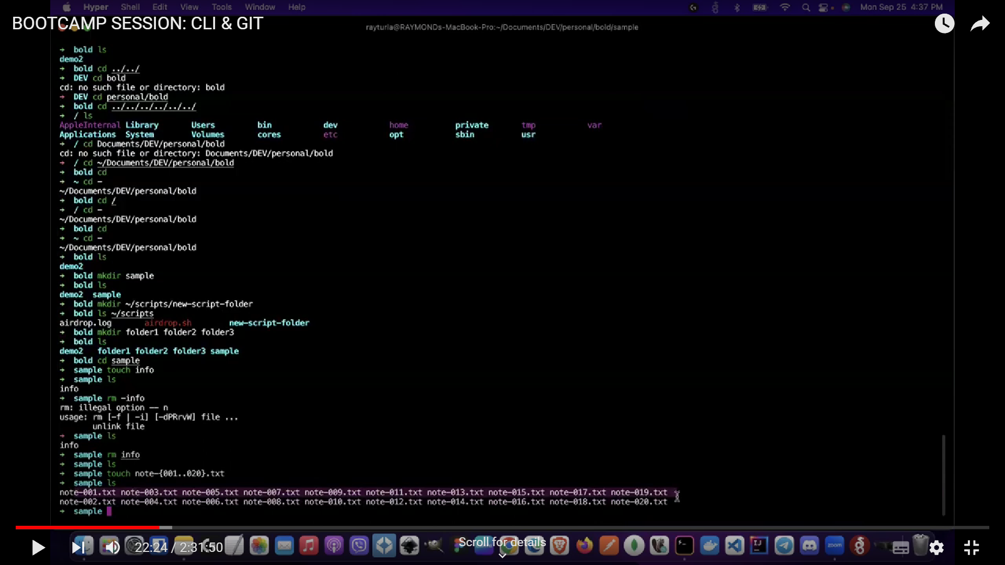

Touch file_name-{001..020}.txt = creates multiple files with names ranging from 1 to 20

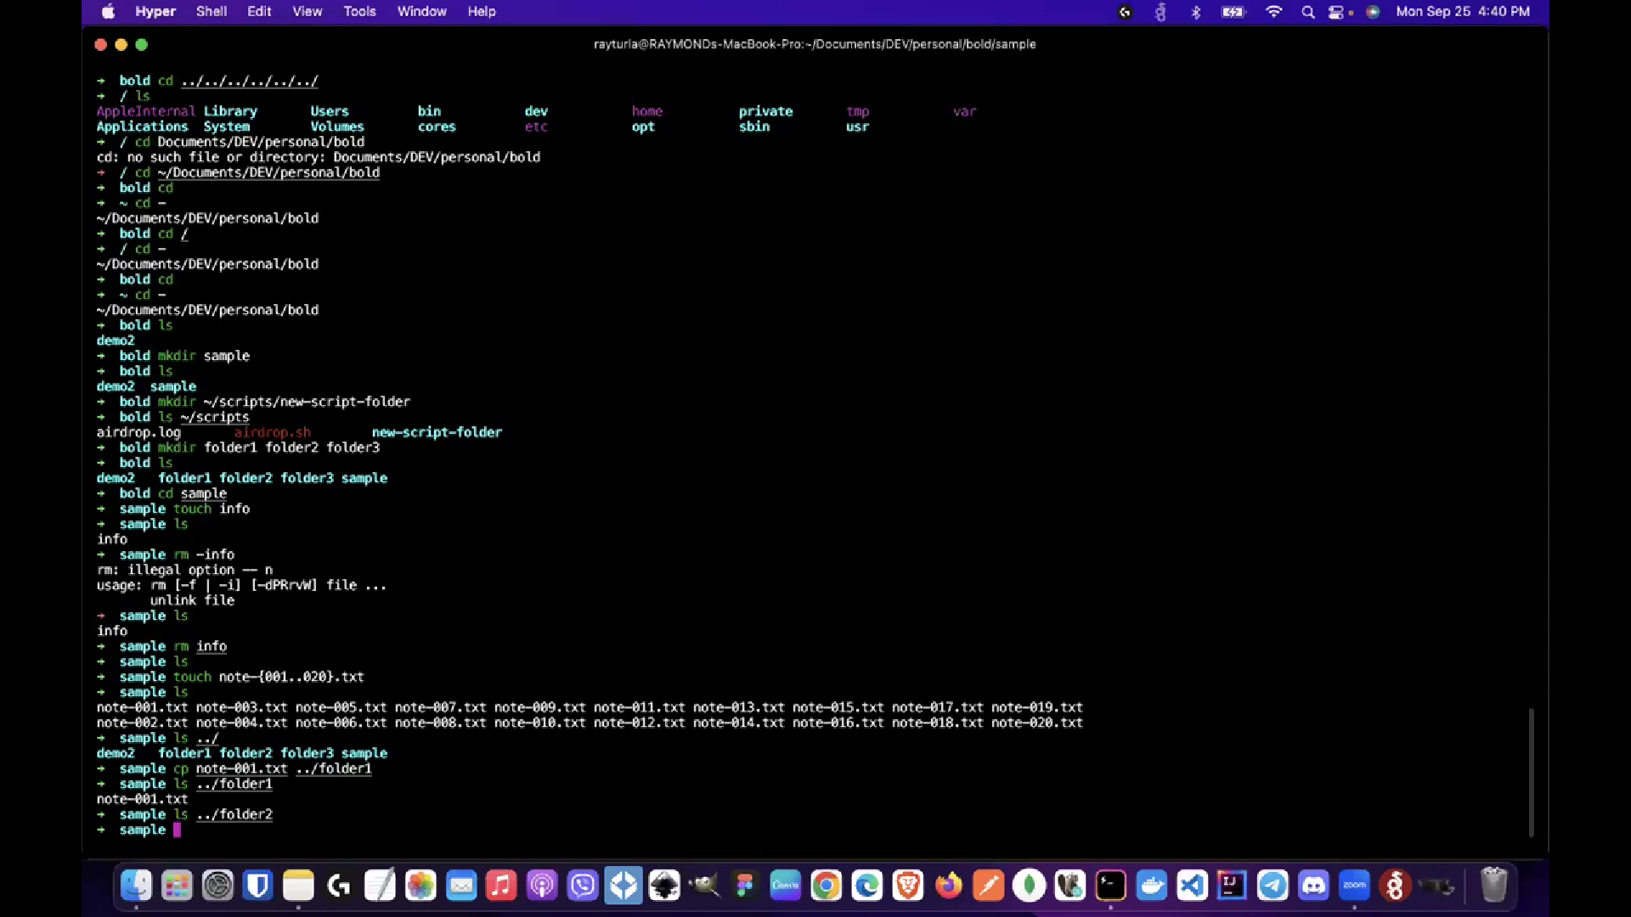

Cp = copies file from <file name> to <target destination>

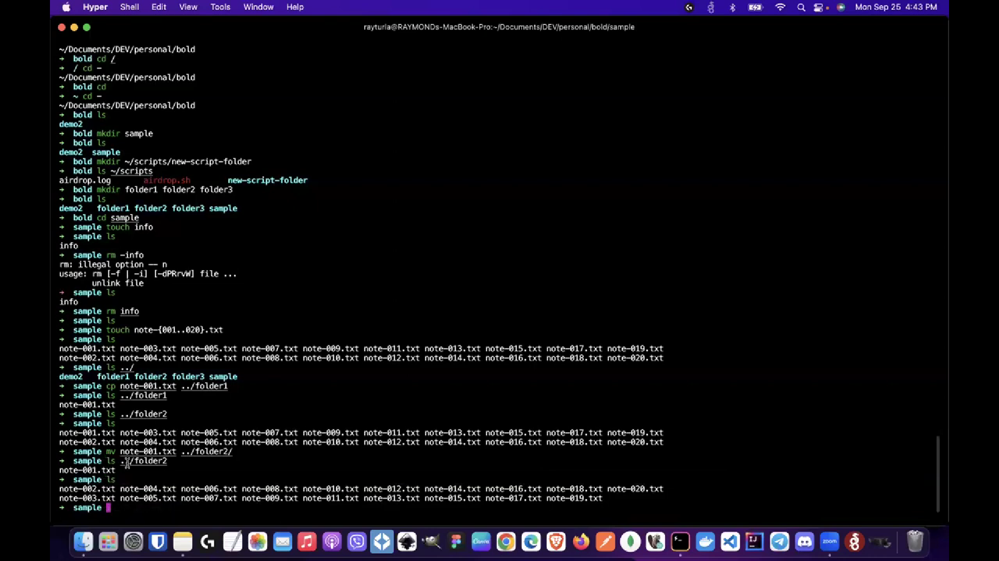

Mv = cut and paste <file name> to <target destination>

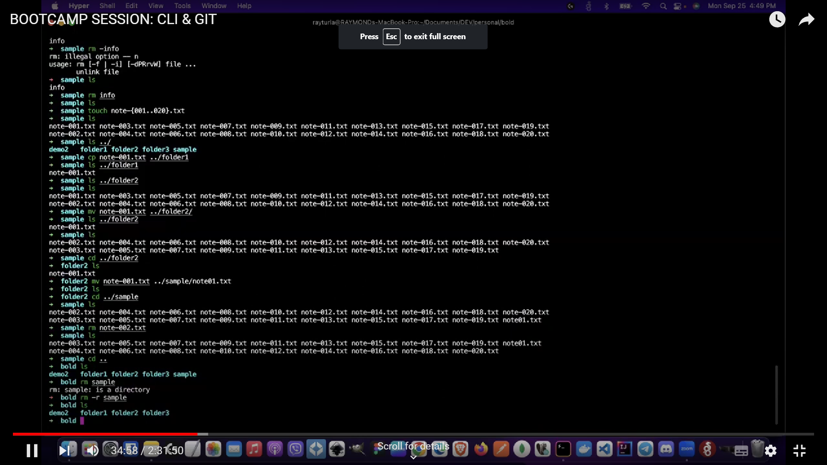

Rm file_name = remove objects (Delete)

Rm -r directory_name = remove directories (Folders)

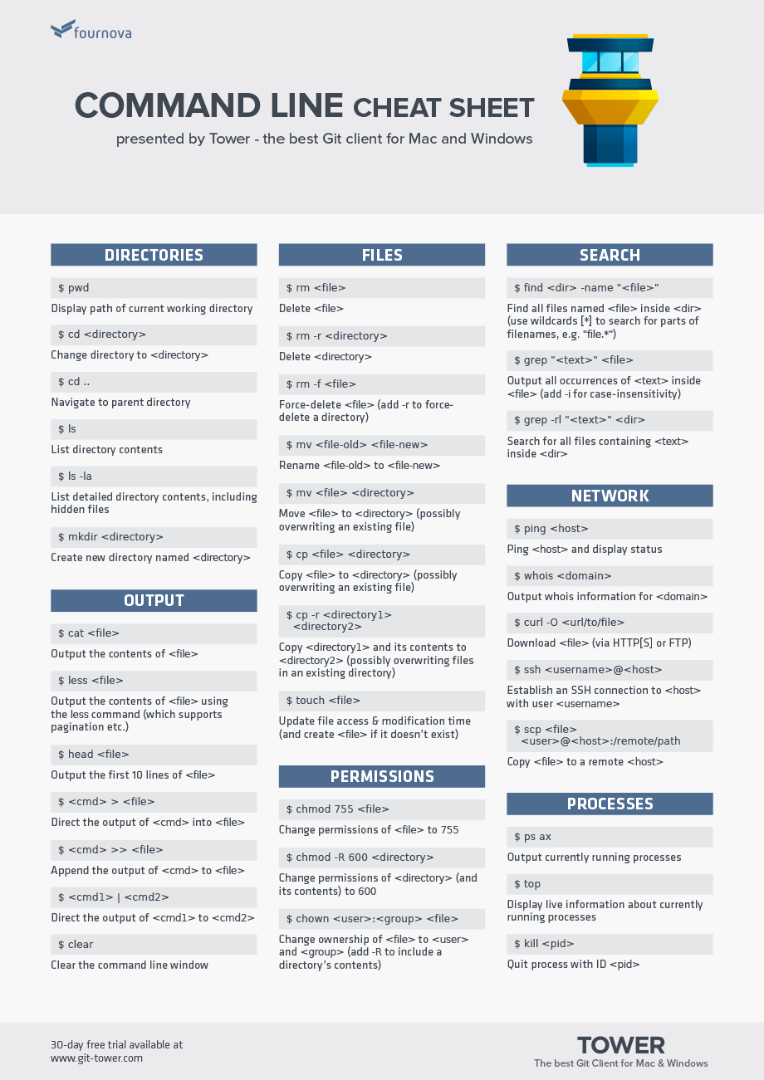

**GIT**

Git is a DevOps tool used for source code management. It is a free and open-source version control system used to handle small to very large projects efficiently. Git is used to tracking changes in the source code, enabling multiple developers to work together on non-linear development. **Github** is an online hosting service for git repositories.

